RDS TASKS

Create MariaDB DB on EC2.

Task Title
Launch an EC2 Instance and Install & Secure MariaDB.

Objective
To create an Amazon EC2 instance using Amazon Linux 2023, install MariaDB Server, secure the database installation, and verify successful connectivity.

Prerequisites
- AWS account
- EC2 key pair (.pem file)
- Security Group with:
  - SSH (22) from your IP
  - MySQL/Aurora (3306) as required
- Basic Linux and MySQL knowledge

Launch EC2 Instance
- Service: EC2
- AMI: Amazon Linux 2023
- Instance Type: t3.micro (Free Tier eligible)
- Instance Name: mariadb
- Storage: 8 GiB (default)
- Security Group:
  - SSH – Port 22
  - MySQL/Aurora – Port 3306
✔ Instance launched successfully and entered Running state.

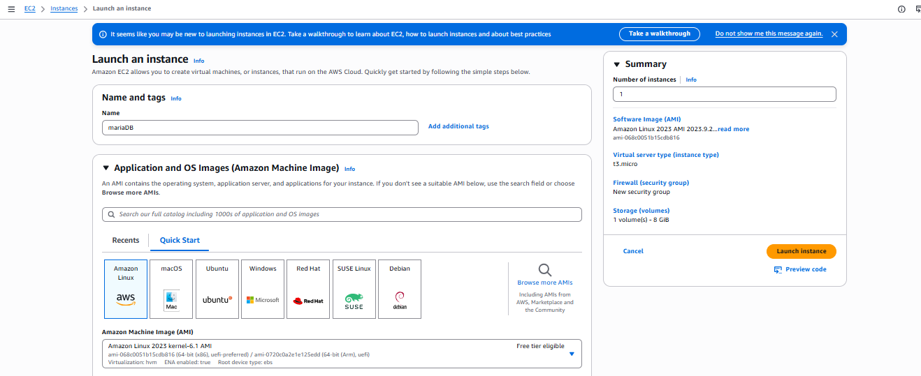

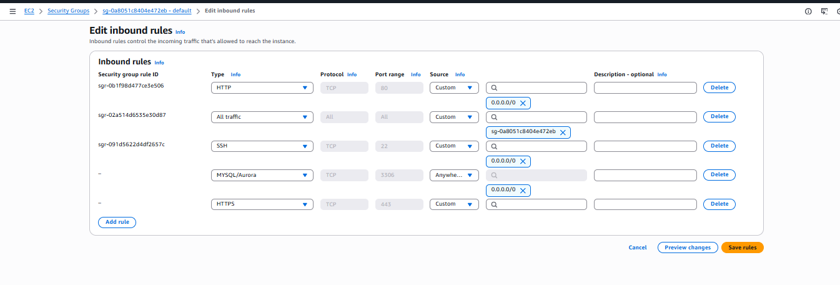
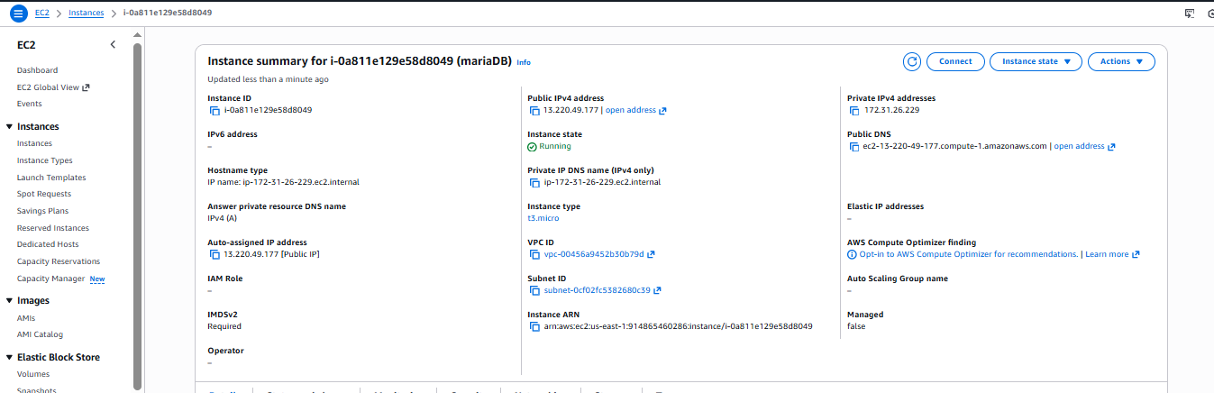

Connect to EC2 Instance
ssh -i "trial.pem" ec2-user@<public-ip>
✔ Successfully connected to the EC2 instance.

Update System Packages
sudo yum update -y
✔ System packages updated successfully.

Install MariaDB Server
sudo yum install mariadb105-server -y
✔ MariaDB Server installed without errors.
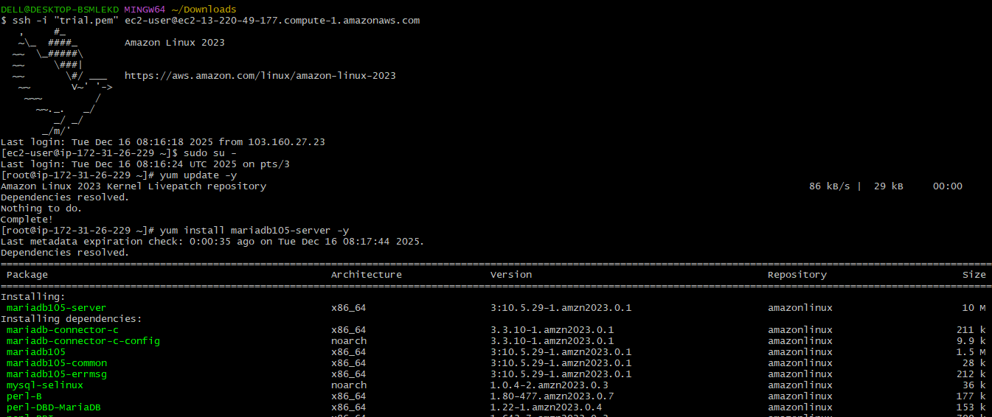
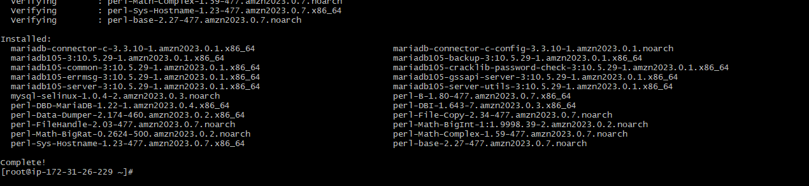

Start and Enable MariaDB Service
sudo systemctl start mariadb
sudo systemctl enable mariadb
✔ MariaDB service started and enabled on boot.

Verify MariaDB Service Status
systemctl status mariadb
✔ Status: Active (running)

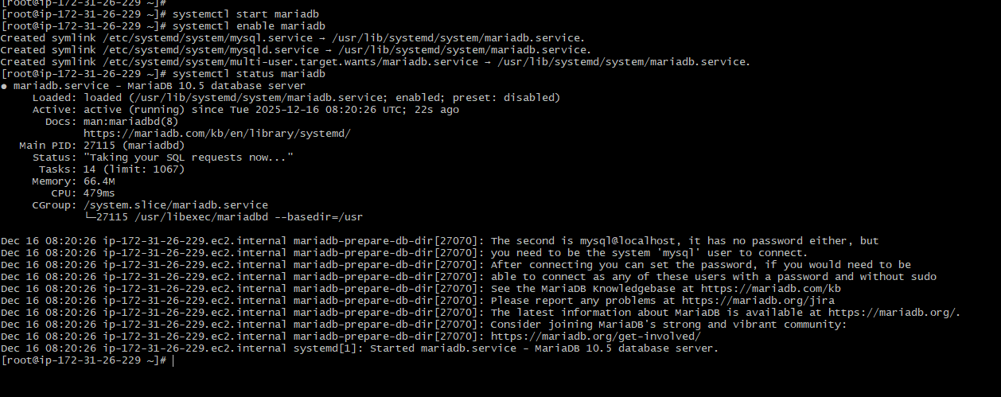

Secure MariaDB Installation
mysql_secure_installation
Actions performed:
- Set root password
- Removed anonymous users
- Disabled remote root login
- Removed test database
- Reloaded privilege tables
✔ MariaDB successfully secured.

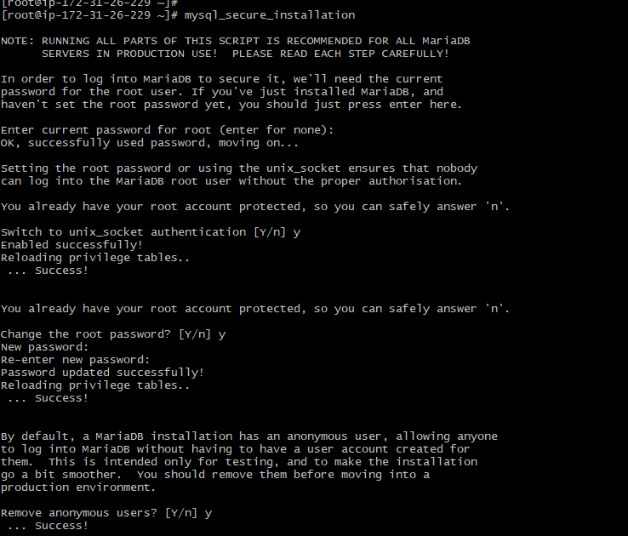
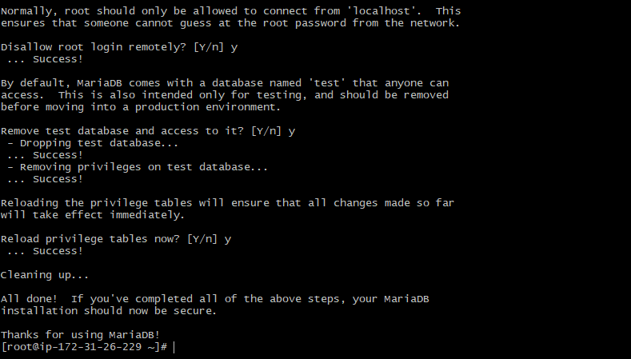

Login to MariaDB
mysql -u root -p
✔ Logged in successfully to the MariaDB monitor.

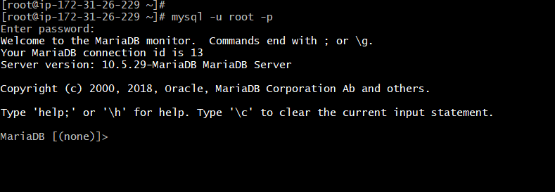

Validation Steps
- EC2 instance status: Running
- MariaDB service status: Active
- Able to log in using root credentials
- Security hardening completed successfully
Issues Faced
Security group inbound rule for port 3306, initially I went with default security group without adding the 3306 port, after encountering the error I have entered rule in the security group.

Conclusion
The EC2 instance was successfully launched using Amazon Linux 2023. MariaDB Server was installed, secured using best practices, and verified for proper operation. The setup is ready for database creation and application integration.

Insert some dummy data.

Task Title
MariaDB Database Creation and Data Validation on EC2 Instance

Objective
To verify the successful installation and operation of MariaDB on an EC2 instance by creating a database, creating a table, inserting records, and validating data retrieval.

Prerequisites
- Running EC2 instance (Linux-based)
- MariaDB installed and service running
- Root or privileged access to MariaDB
- SSH access to the EC2 instance

Step-by-Step Implementation
- Login to the EC2 instance using SSH.
- Access MariaDB using the root user:
mysql -u root -p

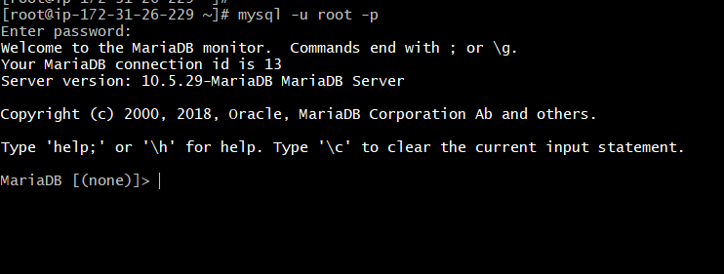

• Verify existing databases:
SHOW DATABASES;
• Create a new database:
CREATE DATABASE BHARATH;
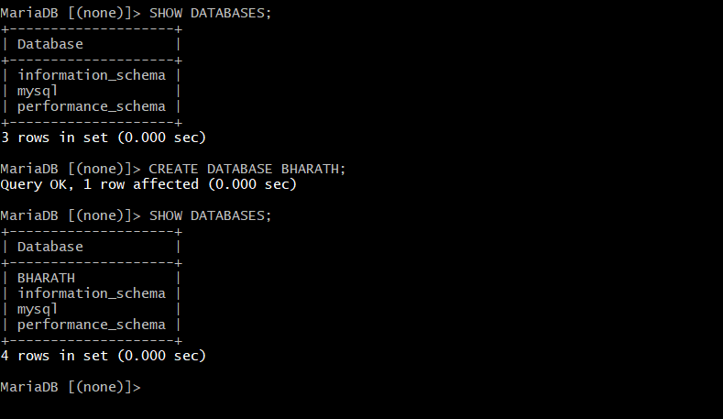
• Switch to the new database:
USE BHARATH;
• Create a table:
CREATE TABLE USERS (
id INT,
name VARCHAR(45)
);
• Insert records into the table:
INSERT INTO USERS VALUES
(1,'BHARATH'),
(2,'KARTHIK'),
(3,'MANI'),
(4,'SAI');

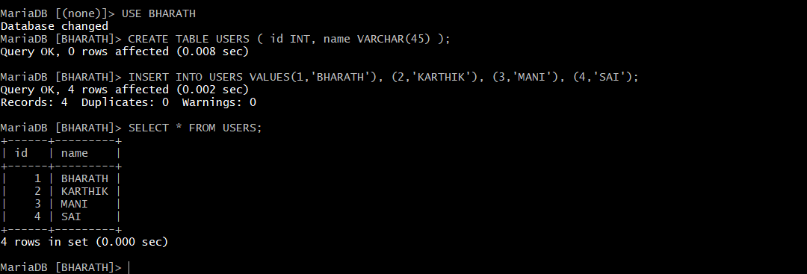

Validation Steps
- Confirm database creation:
SHOW DATABASES;
- Verify table data:
SELECT * FROM USERS;
- Ensure records are displayed correctly without errors.

Issues Faced
• SQL syntax error occurred when multiple SQL commands were executed without proper semicolon separation

Conclusion
MariaDB on the EC2 instance is functioning as expected. Database operations such as creation, table management, data insertion, and retrieval were successfully validated, confirming that the environment is ready for application-level database usage.

Take the backup of dummy data on EC2.

Task Title
MariaDB Database Backup Using mysqldump

Objective
To create a logical backup of the MariaDB database BHARATH using the mysqldump utility and verify the integrity of the backup file.

Prerequisites
- Running EC2 instance with Linux OS
- MariaDB server installed and running
- Root or database user credentials
- Existing MariaDB database named BHARATH
- Access to terminal with root privileges

Step-by-Step Implementation
- Log in to the EC2 instance via SSH.
- Switch to the root user (if not already):
- sudo -i
- Execute the mysqldump command to back up the database:
mysqldump -u root -p BHARATH > BHARATH_BACKUP.sql
Enter the MariaDB root password when prompted.
Verify that the backup file is created:
ls -lh

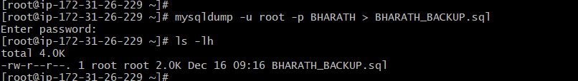

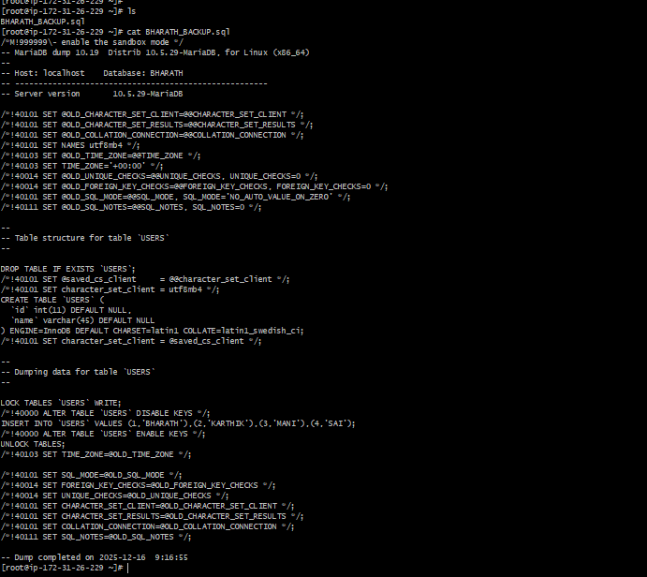

Validation Steps
- Confirm the backup file exists and has a non-zero size:
- ls -lh BHARATH_BACKUP.sql
- View the contents of the backup file:
- cat BHARATH_BACKUP.sql
- Validate the following from the output:
  - Database name: BHARATH
  - Table structure for USERS
  - Insert statements containing user data
  - Successful dump completion timestamp

Conclusion
The MariaDB database BHARATH was successfully backed up using mysqldump. The backup file contains both the database schema and data, confirming a valid and restorable backup. This backup can be used for disaster recovery or database migration purposes.

Launch MariaDB RDS instance.

Task Title
Create Amazon RDS MariaDB Database Instance

Objective
To create and configure an Amazon RDS MariaDB database instance with secure connectivity to an EC2 instance within the same VPC and ensure the database is successfully provisioned and operational.

Prerequisites
- Active AWS account
- Existing EC2 instance in the target VPC
- IAM permissions to create and manage RDS resources
- Basic knowledge of AWS RDS, VPC, and security groups

Step-by-Step Implementation
- Open AWS Management Console and navigate to RDS → Databases
- Click Create database and select Standard create
- Choose MariaDB as the database engine
- Configure database settings:
  - DB instance identifier: bharath-db
  - Master username: admin
  - Credentials: Self-managed password
- Select instance configuration:
  - Instance class: db.t4g.micro
- Configure storage:
  - Storage type: General Purpose SSD (gp2)
  - Allocated storage: 400 GiB
- Configure connectivity:
  - Connect to an existing EC2 instance
  - Network type: IPv4
  - VPC: Default VPC
  - Public access: No
- Configure security:
  - Select existing VPC security group
  - Allow EC2-to-RDS access via security group rules
- Review settings and click Create database

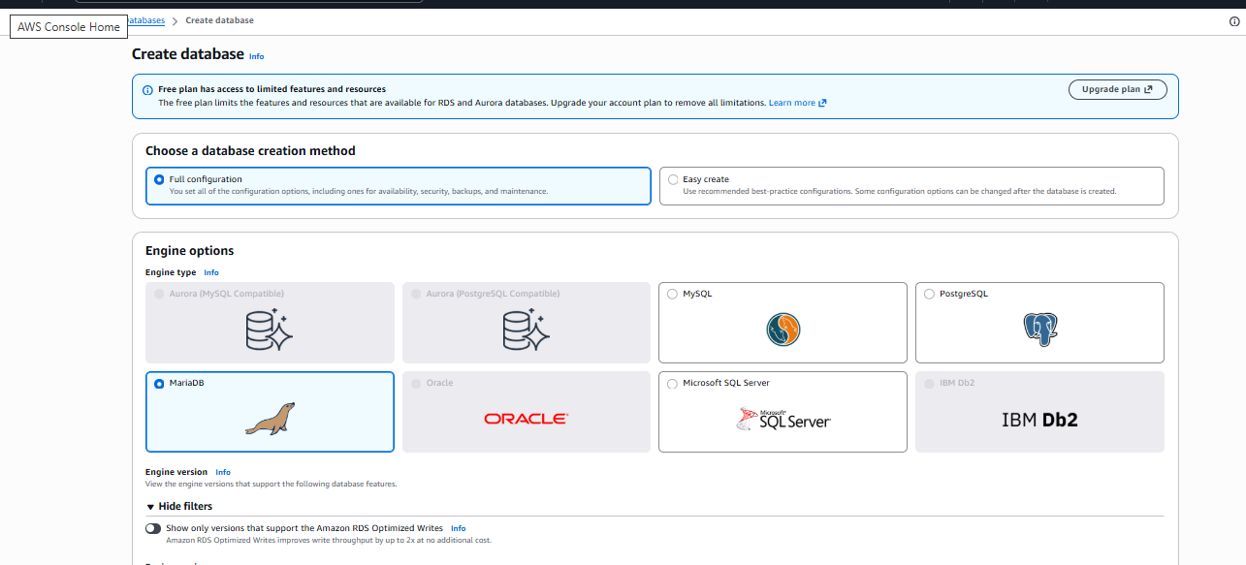
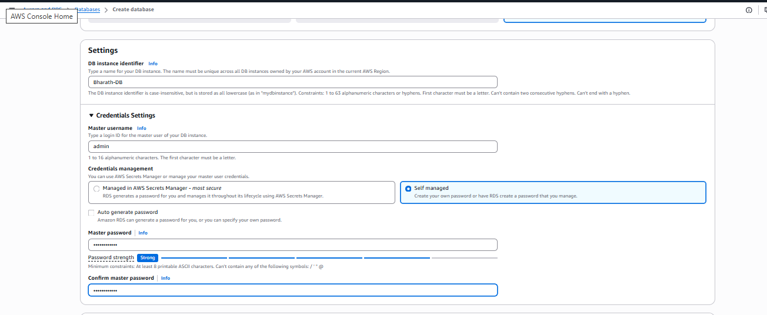
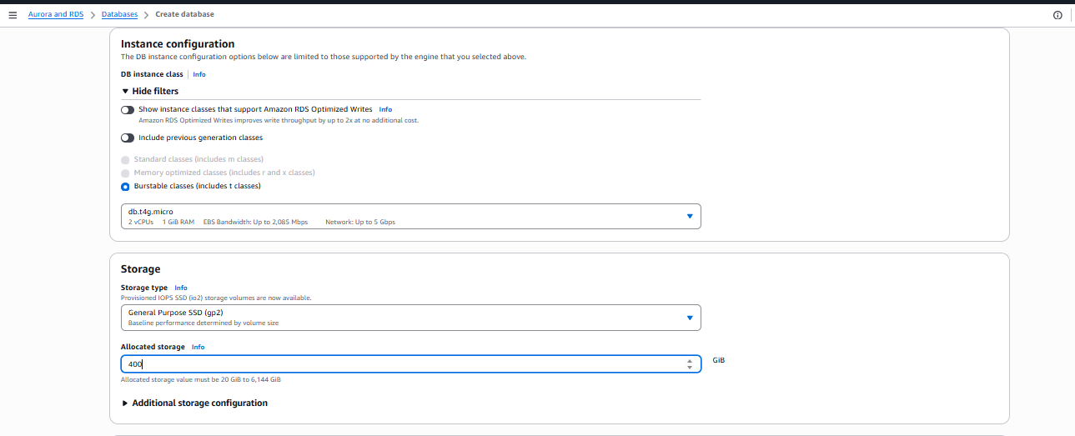
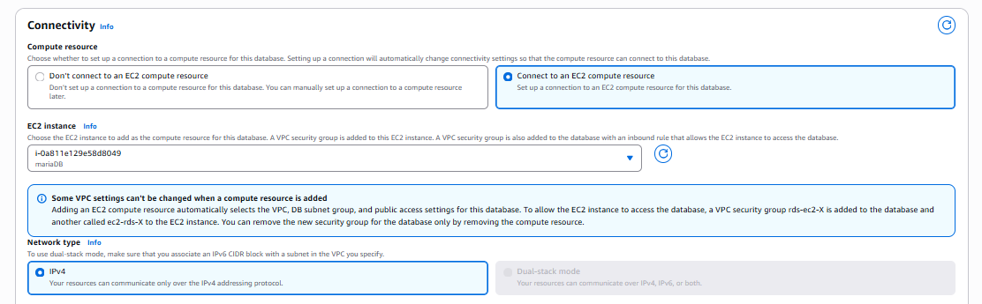
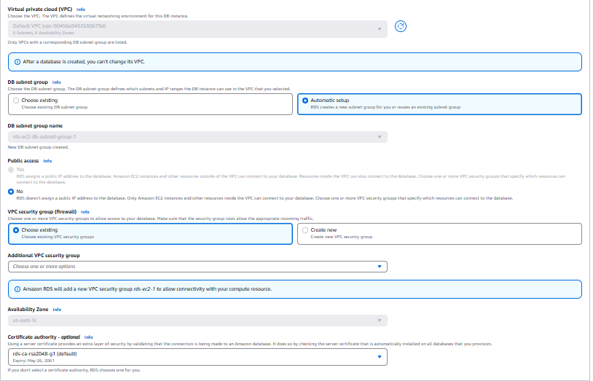
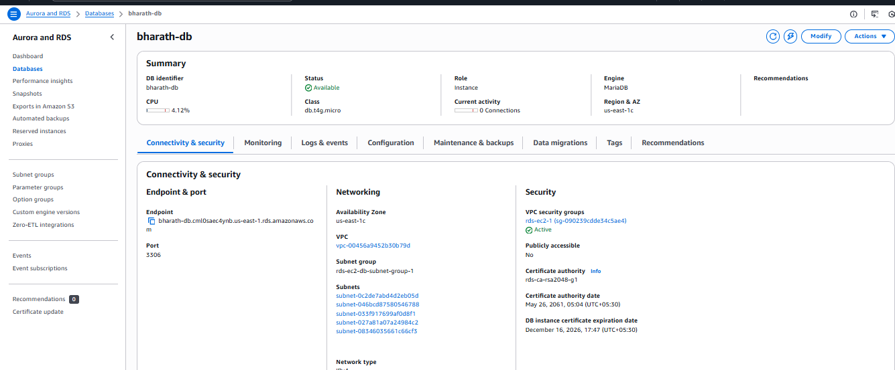

Validation Steps
- Navigate to RDS → Databases
- Verify database status is Available
- Confirm database details:
  - Engine: MariaDB
  - Endpoint and port (3306) are generated
- Validate security:
  - Database is not publicly accessible
  - Correct VPC security group is attached
- (Optional) Connect from EC2 using MariaDB/MySQL client to verify access
Conclusion
The Amazon RDS MariaDB database instance was successfully created and configured. The database is securely deployed within the VPC, connected to an EC2 instance, and ready for application or administrative use.

Migrate database from EC2 to RDS.

Task Title
Connect Amazon EC2 Instance to Amazon RDS MariaDB and Validate Database Access

Objective
To establish secure connectivity between an Amazon EC2 instance and an Amazon RDS MariaDB instance using AWS-managed security group rules, and to validate database access by creating and verifying a database from the EC2 instance.

Prerequisites
- An active AWS account
- EC2 instance in Running state
- Amazon RDS MariaDB instance available and in Available status
- EC2 and RDS instances deployed in the same VPC
- MariaDB client installed on the EC2 instance
- RDS endpoint, port (3306), and master credentials available

Step-by-Step Implementation

1. Connect EC2 Instance to RDS
- Navigate to EC2 → Instances
- Select the EC2 instance
- Click Actions → Networking → Connect RDS database
- Select:
  - Database role: Instance
  - RDS Database: bharath-db (MariaDB)
- Click Connect
AWS automatically updates security groups to allow inbound traffic from the EC2 instance to the RDS instance on port 3306.
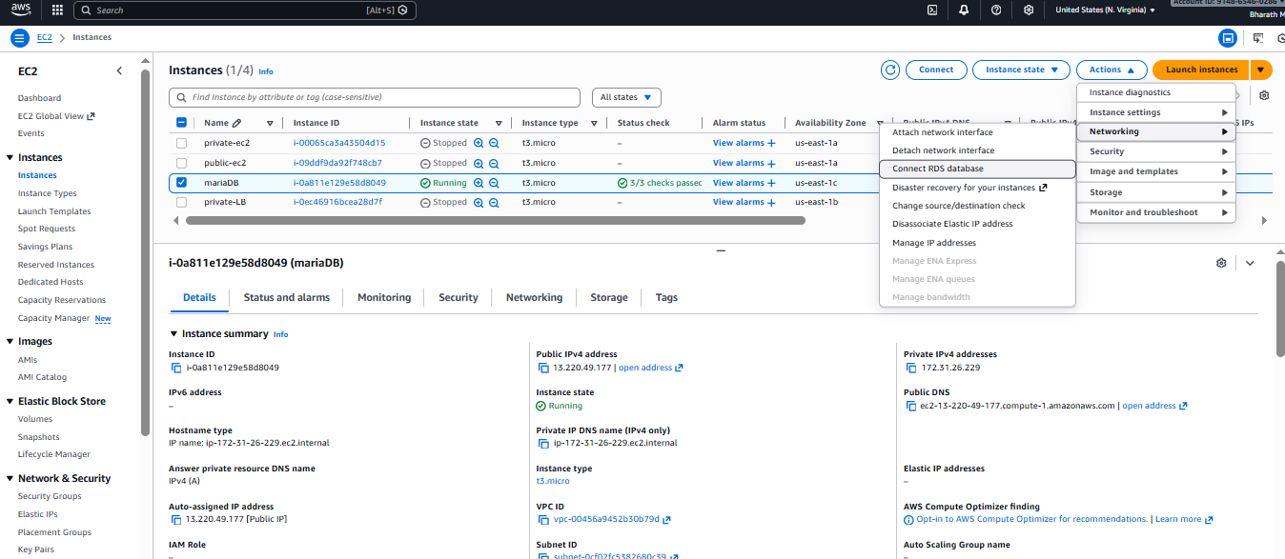

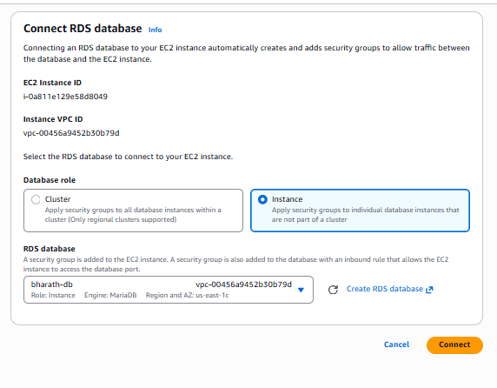

Connect to RDS MariaDB from EC2
Run the following command from the EC2 terminal:
mysql -h bharath-db.<rds-endpoint>.us-east-1.rds.amazonaws.com \
-P 3306 -u admin -p
Successful login confirms network and authentication connectivity.

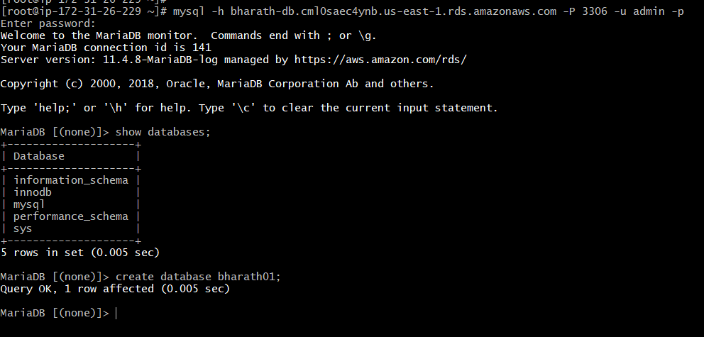
Verify Existing Databases
SHOW DATABASES;
System databases are displayed:
- information_schema
- mysql
- performance_schema
- sys

Create a New Database
CREATE DATABASE bharath01;

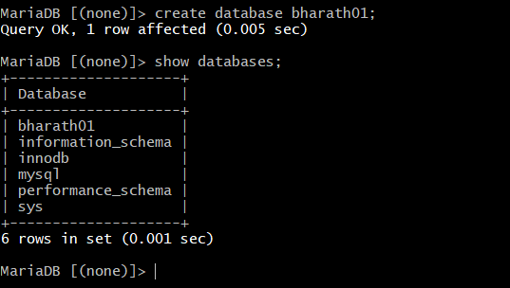

Validate Database Creation
SHOW DATABASES;
The newly created database bharath01 is listed

Switch to the New Database
USE bharath01;

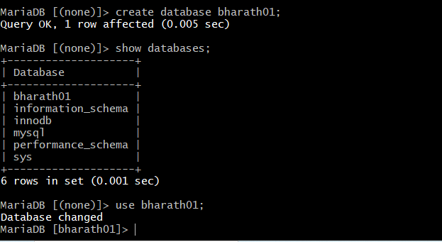
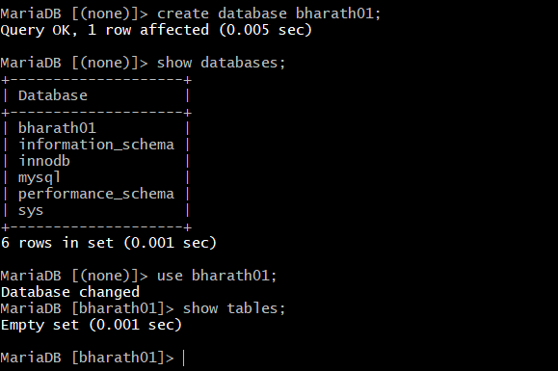
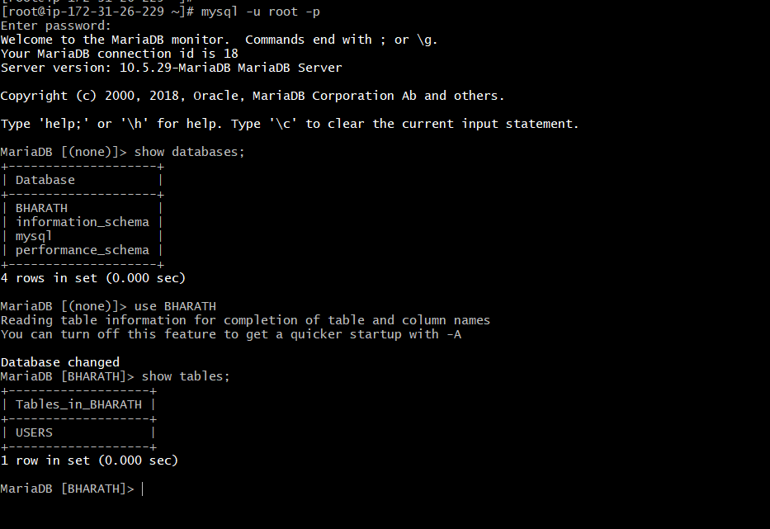

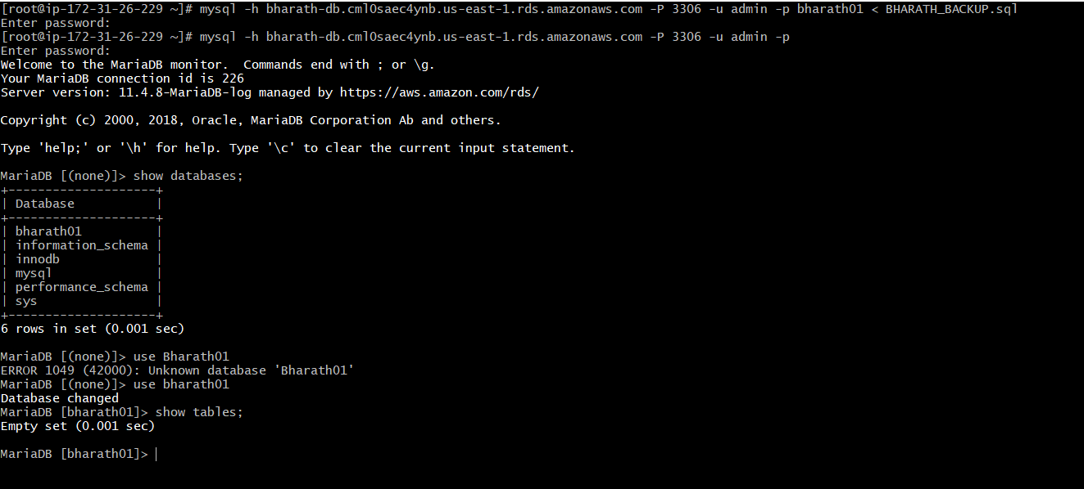

Validation Steps
- EC2 successfully connects to the RDS endpoint
- MariaDB login succeeds without timeout or access errors
- Database creation command executes successfully
- Newly created database appears in SHOW DATABASES output
- Database context switch works as expected

Issues Faced
- Initial error due to case sensitivity in database name (Bharath01 vs bharath01)
- Attempting to access a database before it was created resulted in:
- ERROR 1049 (42000): Unknown database
- Issue resolved by using the correct database name and verifying with SHOW DATABASES

Conclusion
The EC2 instance was successfully connected to the Amazon RDS MariaDB instance using AWS-managed security group rules. Database access was validated by creating and accessing a new database from the EC2 instance. This confirms proper network configuration, authentication, and database functionality.

Install MySQL DB on EC2.

Task Title
Install MySQL Database Server on Amazon EC2

Objective
To install and configure the MySQL database server on an Amazon EC2 instance and verify successful database operation.

Prerequisites
- Amazon EC2 instance in Running state
- SSH access to the EC2 instance
- Security Group allowing:
  - SSH (22) from your IP
  - MySQL (3306) if remote access is required
- Sudo/root privileges on the instance

. Connect to the EC2 Instance
ssh -i key.pem ec2-user@<EC2-Public-IP>

Update the System
sudo yum update -y

Install MySQL Server
Amazon Linux installs MySQL 8.x by default:
sudo yum install mysql-server -y

Start and Enable MySQL Service
sudo systemctl start mysqld
sudo systemctl enable mysqld

Verify MySQL Service Status
sudo systemctl status mysqld
Status should be active (running).

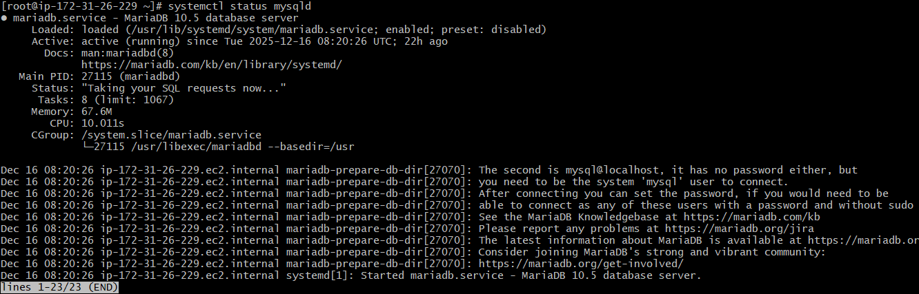

Secure MySQL Installation
sudo mysql_secure_installation
Recommended options:
- Set root password → Yes
- Remove anonymous users → Yes
- Disallow root login remotely → Yes
- Remove test database → Yes
- Reload privilege tables → Yes

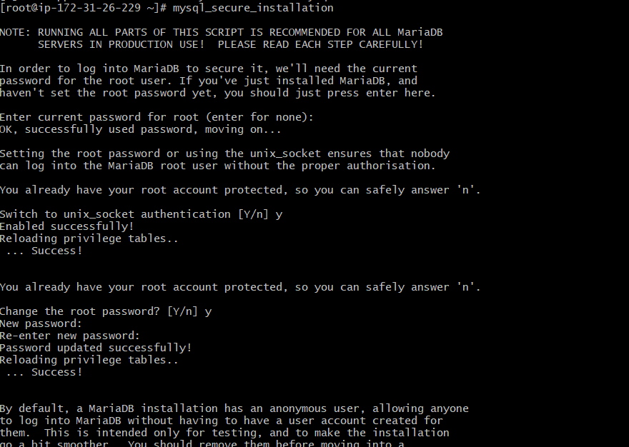

Log in to MySQL
mysql -u root -p

Verify MySQL Installation
SHOW DATABASES;

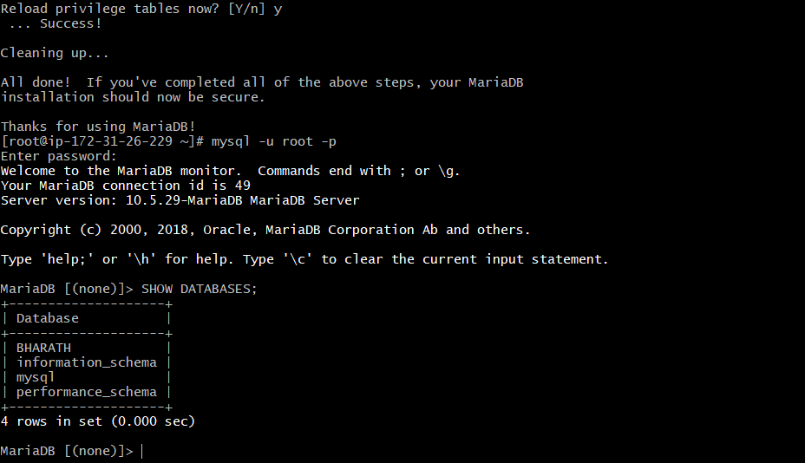

Validation Steps
- MySQL service is running
- Login to MySQL succeeds
- Database creation and access works
- No permission or service errors observed

Issues Faced
- mysqld: command not found → MySQL not installed correctly
- MySQL service not starting → Check logs:
sudo journalctl -xe
- Port 3306 blocked → Update EC2 Security Group

Conclusion
MySQL was successfully installed and configured on the EC2 instance. The database service is running and accessible, and database operations are functioning as expected.

Launch MySQL RDS image.

Task Title
Create Amazon RDS MySQL Database (Free Tier)

Objective
To create a MySQL database instance on Amazon RDS using Free Tier–eligible settings and connect it to an EC2 instance for application or testing purposes.

Database Creation Method
- Full configuration
  - You manually selected availability, security, storage, and connectivity options.

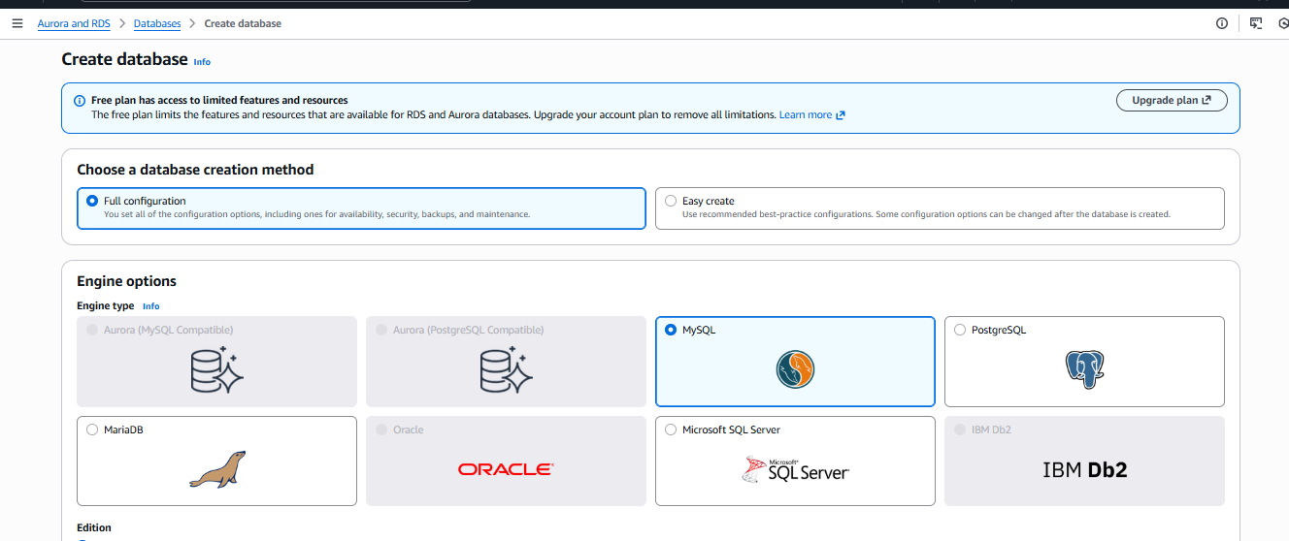

Engine Options
- Engine: MySQL
- Edition: MySQL Community
- Engine version: MySQL 8.0.43
- Template: Free Tier
  - Ensures cost-free usage within AWS Free Tier limits.

Availability & Durability
- Deployment option: Single-AZ DB instance
- Reason:
  - Free Tier eligible
  - Lower cost
  - No standby replica (not for production HA use)

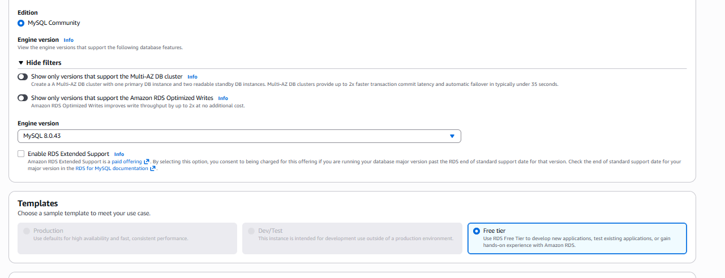
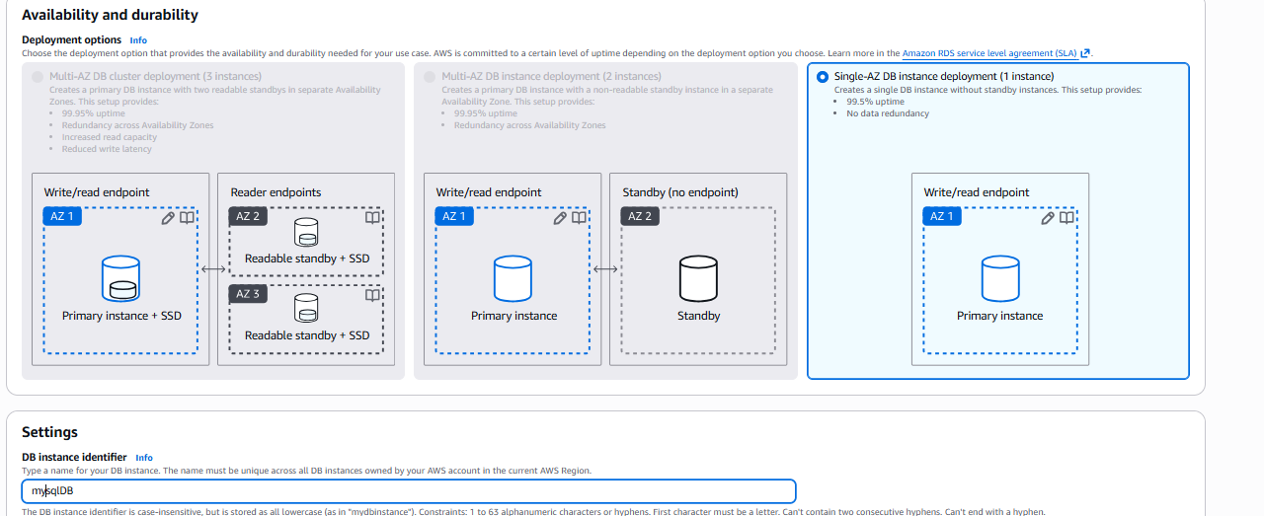

DB Settings
- DB instance identifier: mysqldb
- Master username: admin
- Credential management: Self-managed
- Authentication: Password-based login

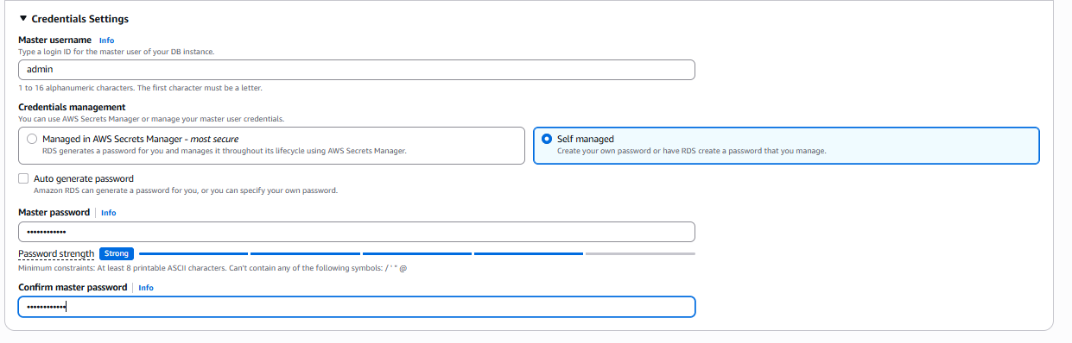

Instance Class
- DB instance class: db.t4g.micro
  - Free Tier eligible
  - Suitable for development and learning workloads

Storage
- Storage type: General Purpose SSD (gp2)
- Allocated storage: 20 GiB
- Reason: Minimum storage required and Free Tier eligible

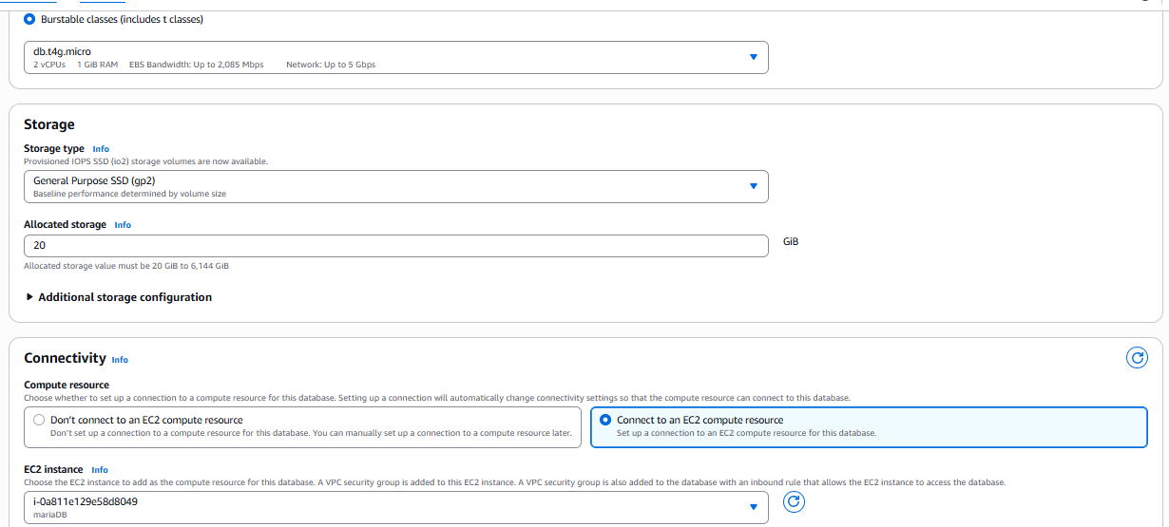

Connectivity
- Connected to EC2 compute resource: ✅ Yes
- VPC: Default/custom VPC (as shown)
- Security group:
  - Allows inbound MySQL (port 3306) from the selected EC2 instance
- Public accessibility: No (recommended for security)

Database Status (Post-Creation)
From the final screen:
- Status: Available
- Engine: MySQL Community
- Endpoint: Provided (used for EC2 connection)
- Port: 3306
- AZ: Single Availability Zone

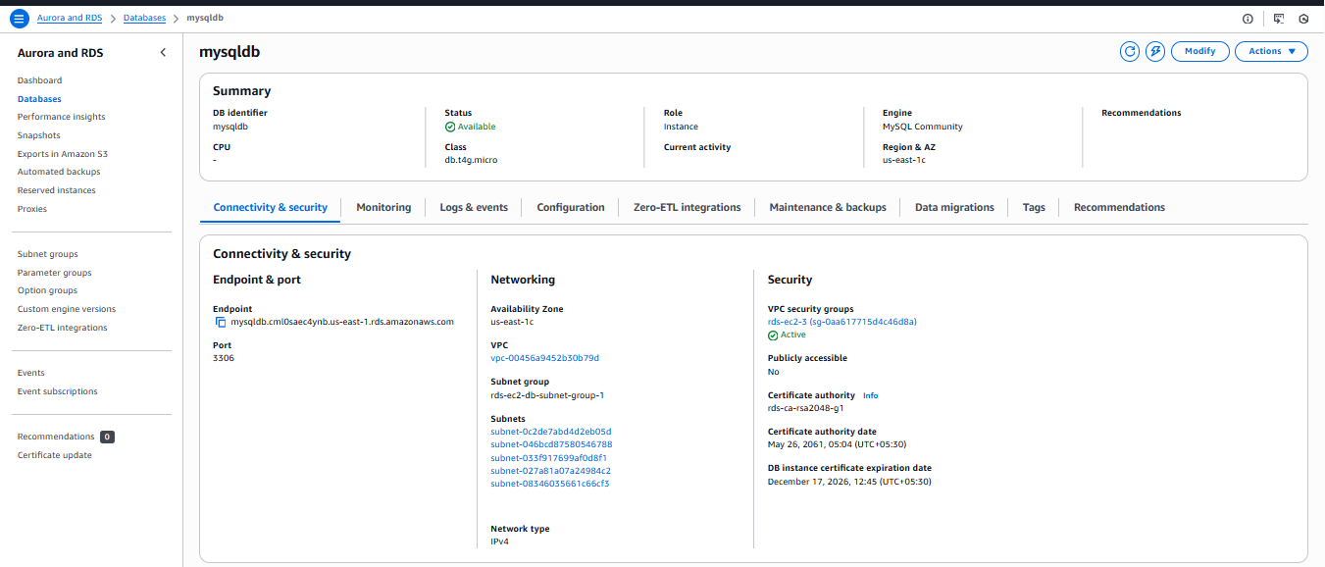

Validation Steps
- Verify DB status
  - Go to RDS → Databases
  - Confirm status shows Available
- Check endpoint & port
  - Navigate to Connectivity & security
  - Note the Endpoint and Port 3306
- Validate EC2 connectivity
  - SSH into the connected EC2 instance
  - Run:
  - mysql -h <rds-endpoint> -u admin -p
- Confirm database access
  - Successful login confirms:
    - Security group rules
    - Network connectivity
    - Credentials are correct

Issues Faced
- DB stuck in Creating state (wait a few minutes)
- Connection timeout due to:
  - Missing inbound rule on port 3306
  - EC2 not in the same VPC
- Authentication failure due to incorrect password

Conclusion
You successfully created an Amazon RDS MySQL Free Tier database, configured with:
- Secure Single-AZ deployment
- Free Tier–eligible instance and storage
- EC2 connectivity for application access
This setup is ideal for learning, testing, and development environments.

Configure Multi-AZ.

Configuring Multi-AZ is not possible with the free account

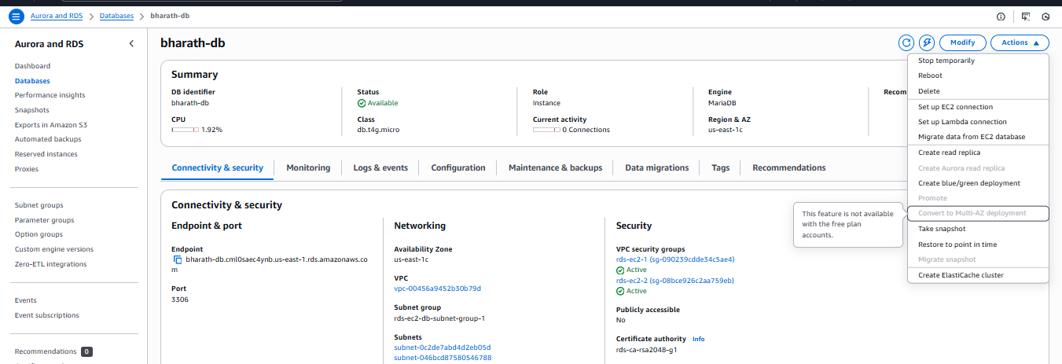

Take backup of DB and restore the DB.

Task Title
Manual Snapshot Creation for Amazon RDS (MariaDB)

Objective
To create a manual DB snapshot of an existing Amazon RDS MariaDB instance (bharath-db) for backup, recovery, and audit purposes.

Prerequisites
- An existing Amazon RDS DB instance in Available state
- Required IAM permissions:
  - rds:CreateDBSnapshot
  - rds:DescribeDBSnapshots
- AWS Management Console access
- DB instance identifier known (bharath-db)

Step-by-Step Implementation

Step 1: Navigate to RDS Database
- Open AWS Management Console
- Go to RDS → Databases
- Select the DB instance bharath-db

Step 2: Initiate Snapshot Creation
- Click Actions (top-right corner)
- Select Take snapshot

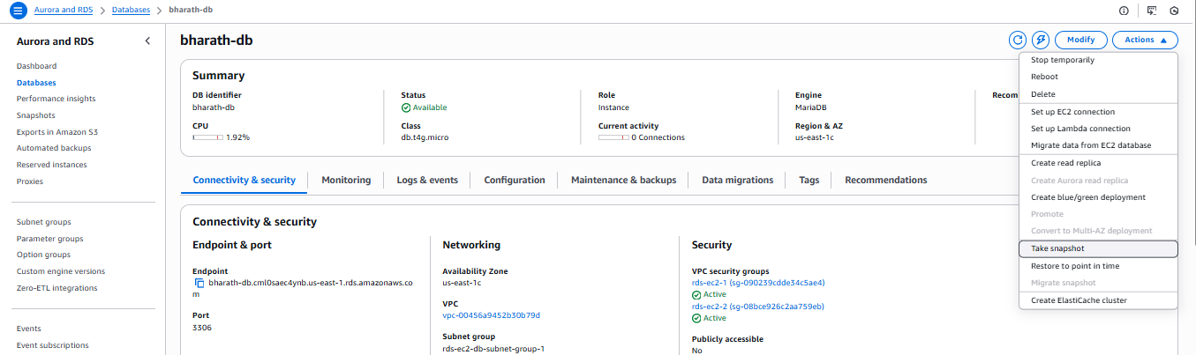

Step 3: Configure Snapshot
- Snapshot type:
  - Select DB instance
- DB instance:
  - bharath-db (auto-selected)
- Snapshot name:
  - Enter backup-db
- Click Take snapshot

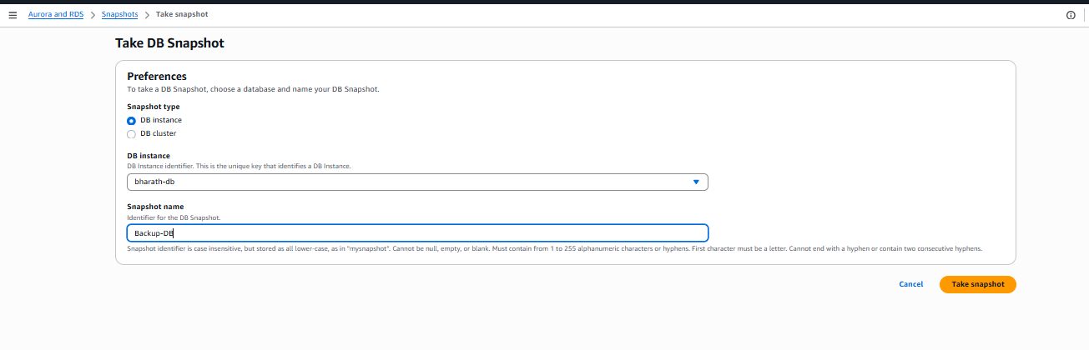

Step 4: Monitor Snapshot Creation
- Navigate to RDS → Snapshots
- Select snapshot backup-db
- Observe the Status:
  - Initially: Creating
  - Final: Available

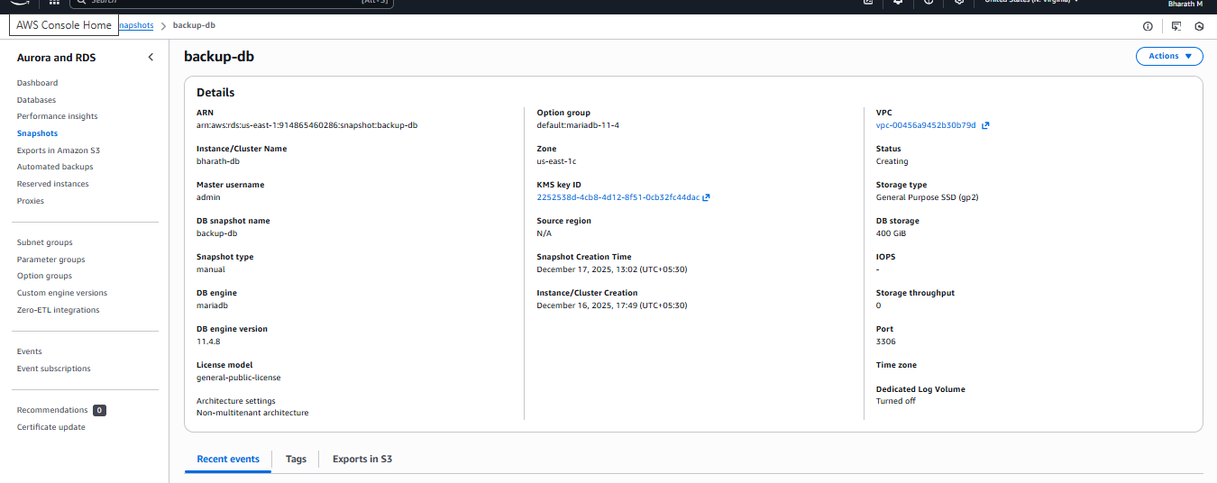

Validation Steps
✔ Snapshot appears under Snapshots section
✔ Snapshot name matches backup-db
✔ Snapshot type is Manual
✔ DB engine: MariaDB
✔ Source DB: bharath-db
✔ Snapshot status changes to Available
✔ Snapshot shows correct engine version and storage size

Conclusion
The manual DB snapshot backup-db was successfully created for the Amazon RDS MariaDB instance bharath-db. This snapshot can be used for:
- Point-in-time recovery
- Creating a new RDS instance
- Disaster recovery and auditing purposes

Create read replica.

Task Title
Create a Read Replica for Amazon RDS MariaDB

Objective
To create a read replica of an existing Amazon RDS MariaDB instance (bharath-db) to support read scalability and high availability.

Prerequisites
- An existing RDS MariaDB primary instance in Available state
- Automated backups enabled on the source DB
- Proper VPC, subnet group, and security groups
- IAM permissions to create RDS instances
- Sufficient DB instance quota in the AWS account

1. Navigate to RDS
- Open AWS Console → RDS → Databases
- Select the source database: bharath-db

2. Initiate Read Replica Creation
- Click Actions → Create read replica

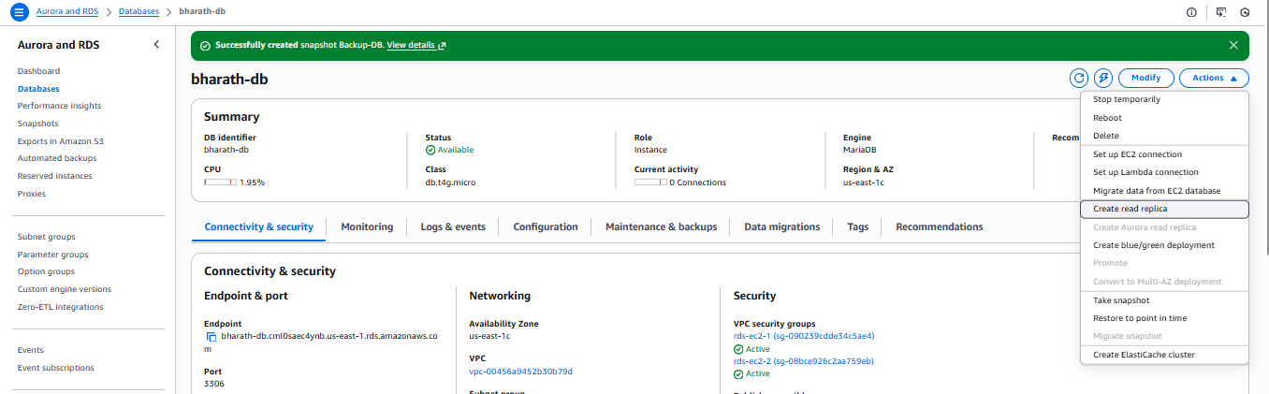

3. Configure Replica Settings
- Source DB Instance: bharath-db
- DB Instance Identifier: bharathdb-replica
- DB Engine: MariaDB
- DB Instance Class: db.t4g.micro
- Region: US East (N. Virginia)
- Availability Zone: us-east-1b

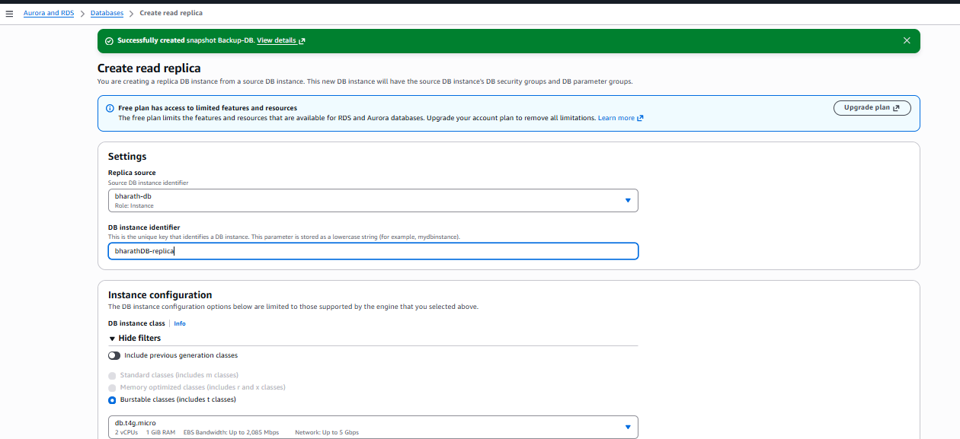

4. Storage Configuration
- Storage Type: General Purpose SSD (gp2)
- Allocated Storage: 400 GiB
- Storage configuration is set to the latest versio

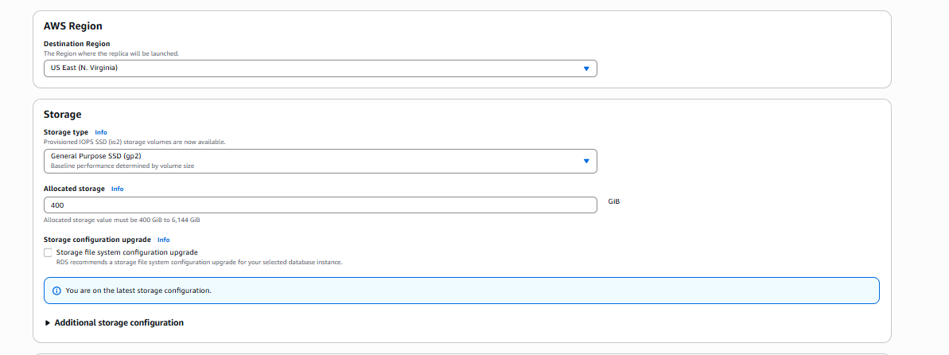

5. Connectivity & Security
- VPC: Same as source DB
- DB Subnet Group: rds-ec2-db-subnet-group-1
- Public Access: Not publicly accessible
- VPC Security Groups:
  - rds-ec2-1
  - rds-ec2-2

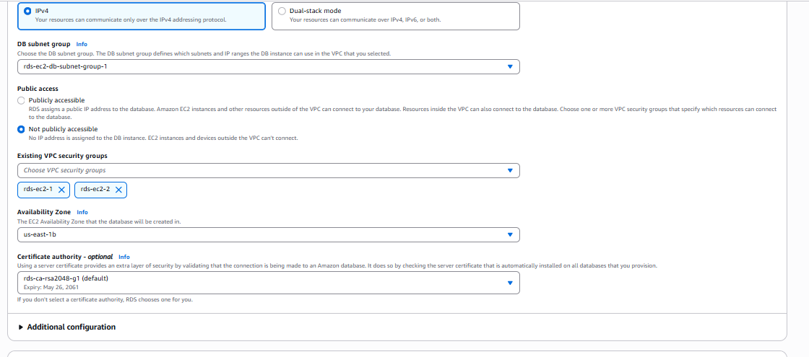

6. Additional Configuration
- Encryption: Enabled
- Automated Minor Version Upgrade: Enabled
- Deletion Protection: Disabled

7. Create Read Replica
- Click Create read replica

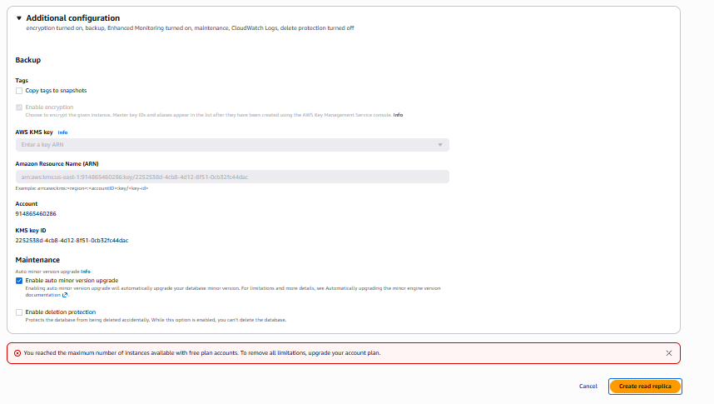

Validation Steps
- Verify the new DB instance appears in the Databases list
- Check DB role is shown as Replica
- Confirm replication source is bharath-db
- Monitor replication lag using CloudWatch metrics

Issues Faced

❌ Error Encountered
You reached the maximum number of instances available with free plan accounts.

Root Cause
- AWS Free Tier accounts have strict limits on:
  - Number of RDS instances
  - Total DB instance count per region
- A read replica counts as a separate DB instance

Conclusion
The read replica configuration was correct, but creation failed due to Free Tier DB instance limits. To proceed, the account must either free up an existing DB instance or upgrade the AWS plan. Once limits are resolved, the read replica can be successfully created for improved read scalability.

